Read Me

1. Open TravelBro.xcworkspace File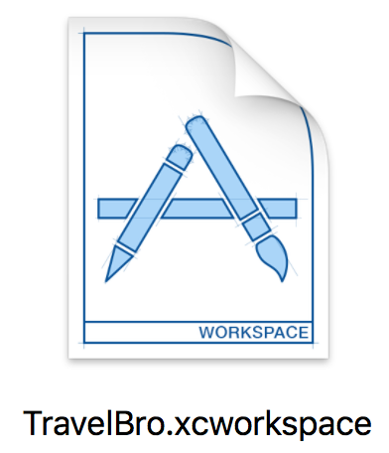
2. Note: This application is developed using the latest version of Swift, Xcode and El Capitan OS. So please run the app in the latest version else there might be build errors in the older version
3. Clean the solution

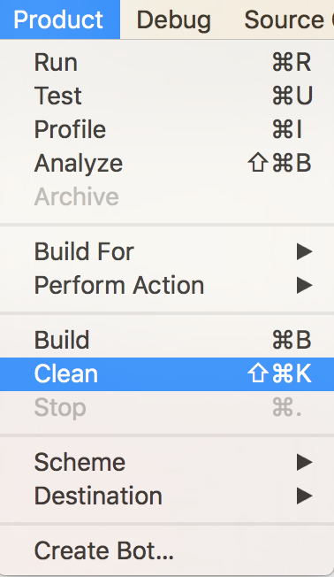

1. Build the solution

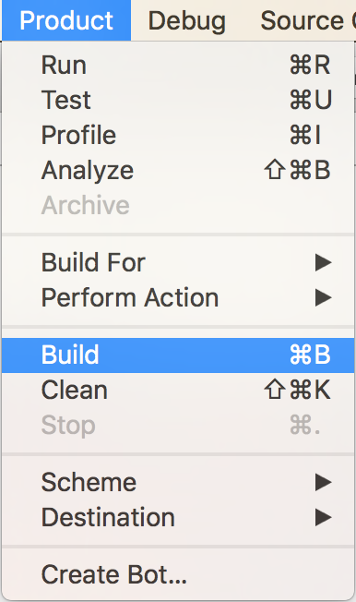

1. Run the app

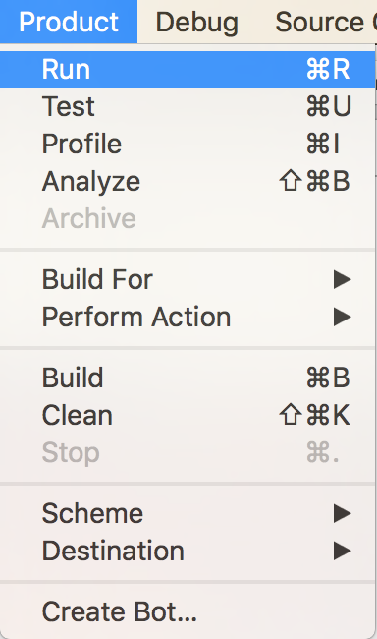

1. Simulate the Location - This is important since we are using location services

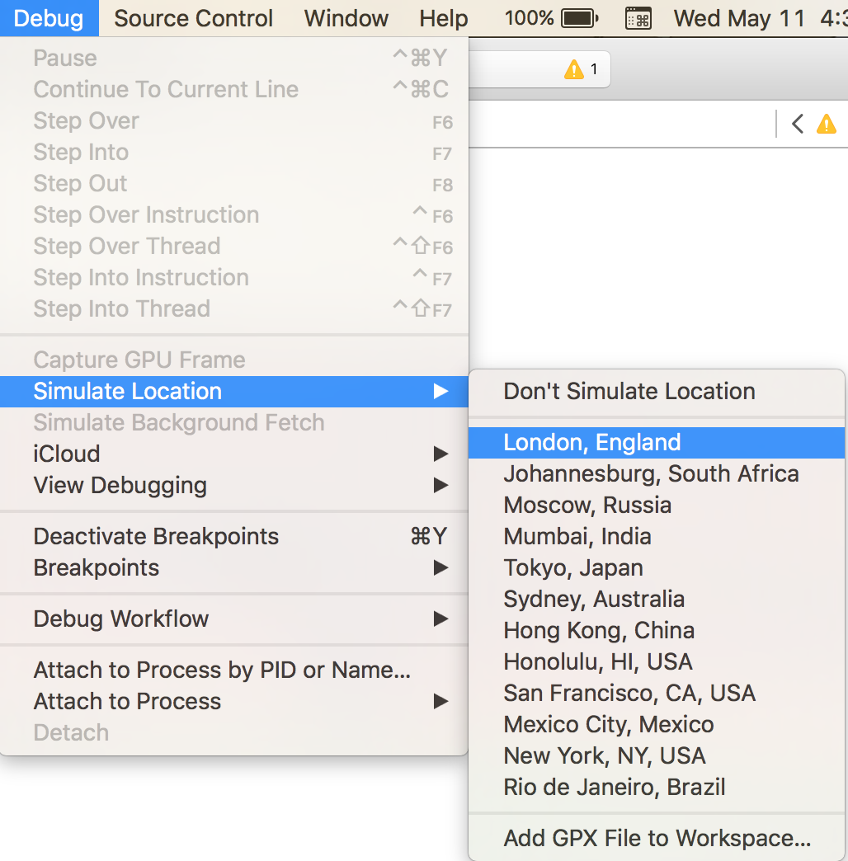

1. Click on Existing login
2. UserName :  admin
3. Password :   admin

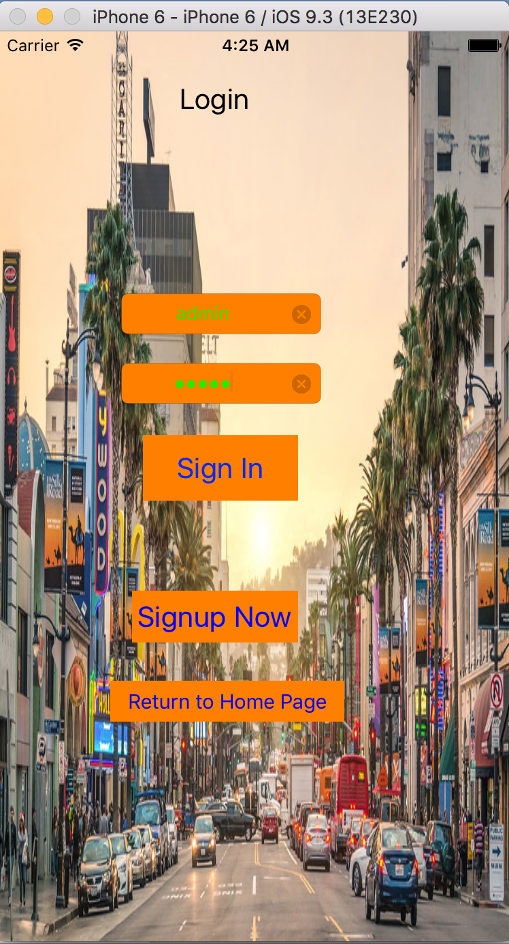

1. Search for the type of place you need to visit at the top menu. This is a dropdown menu

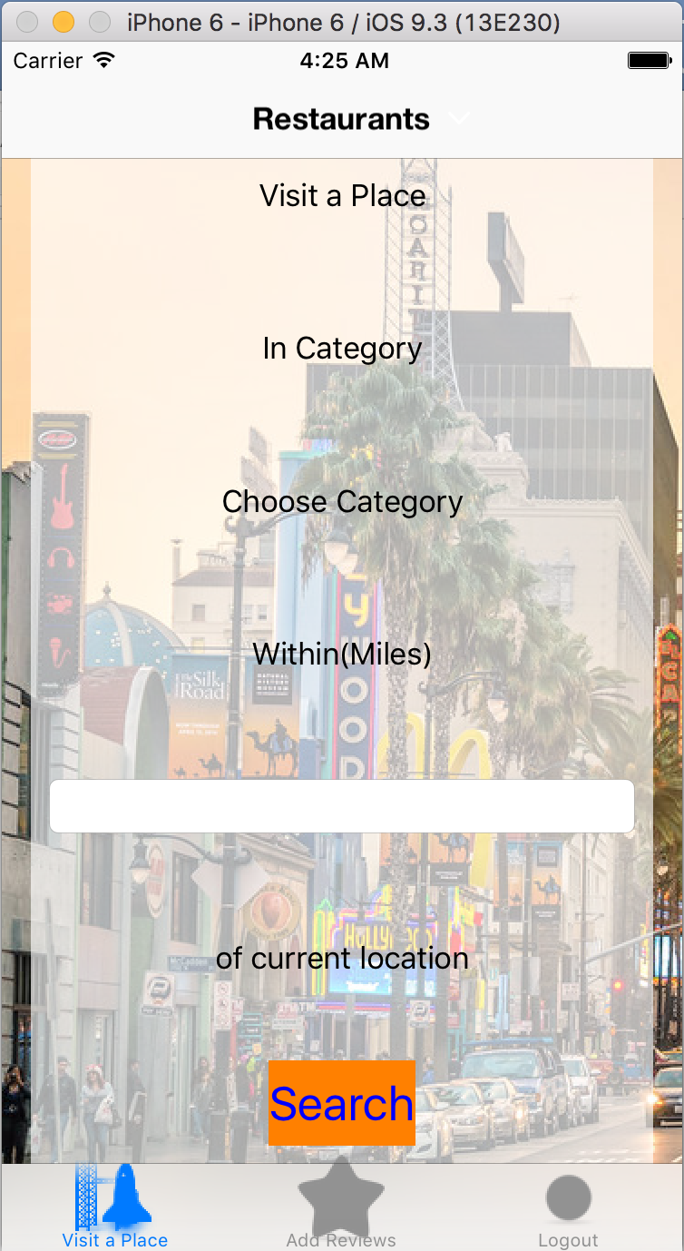

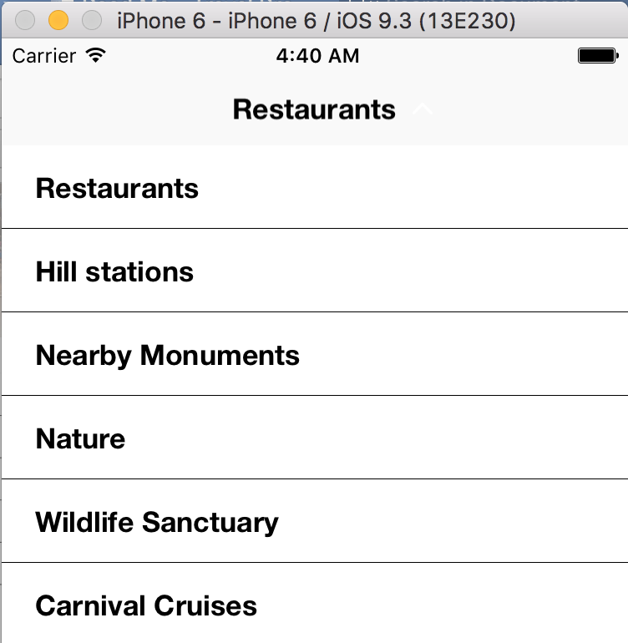

1. Enter the radius/miles for the same. i.e  600
2. Click on Search

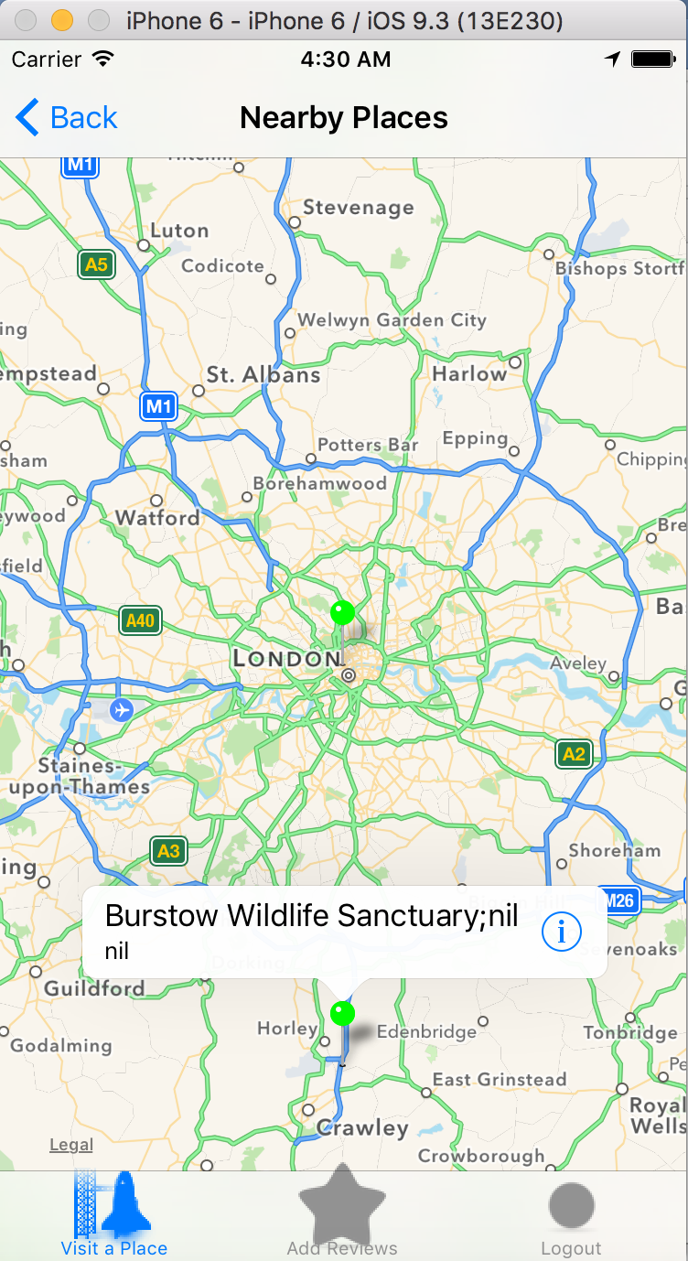

1. Click on any one pin.

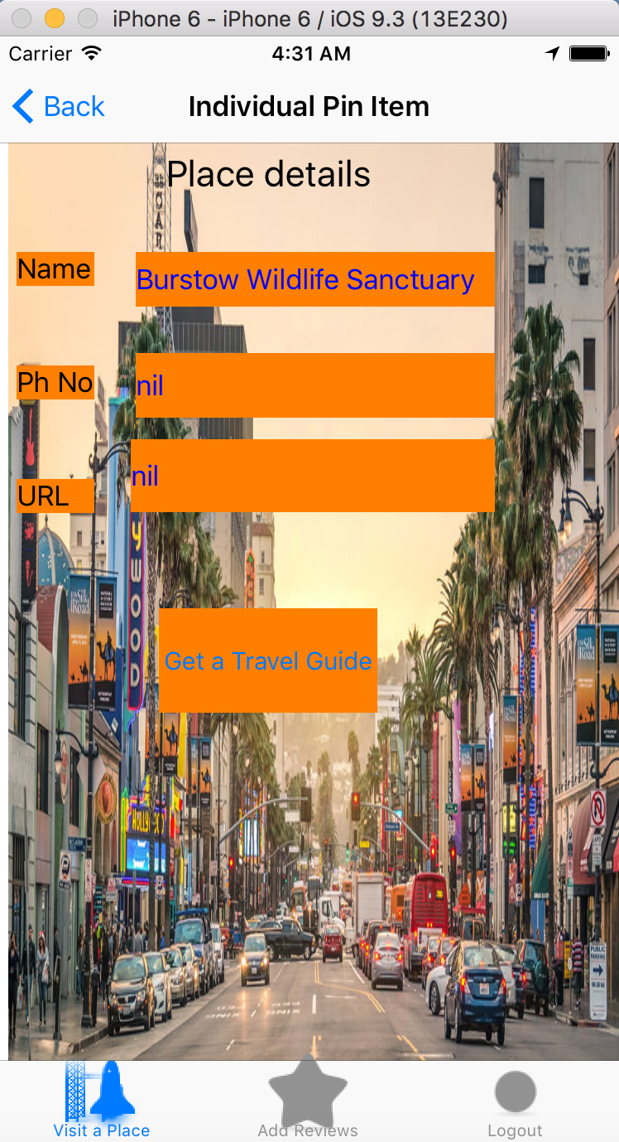

1. Click on the button once displayed with the pin.
2. This redirects to the next page where we can hire a guide

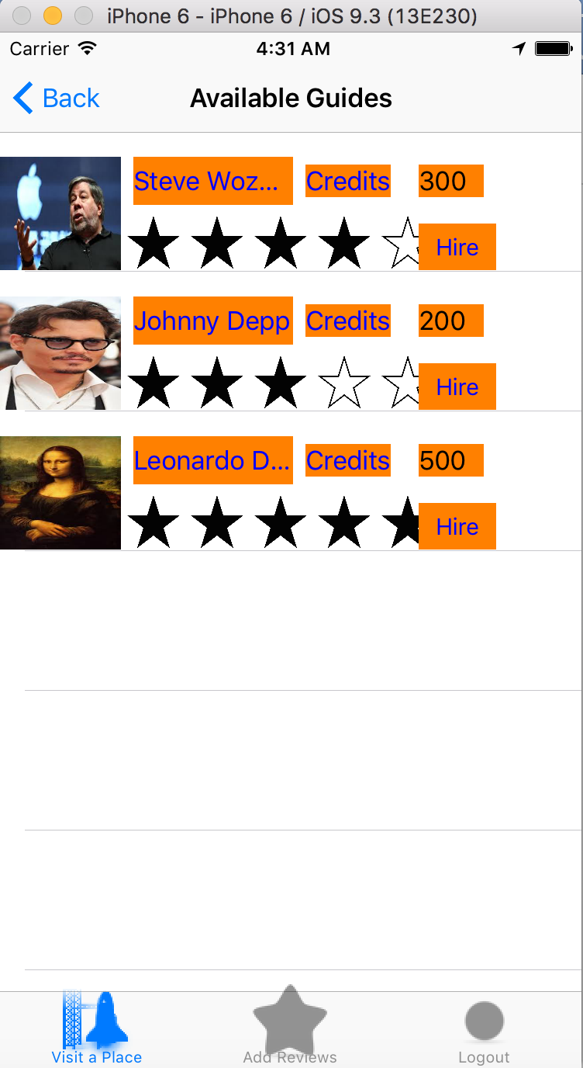

1. Click on Hire a guide button
2. Click on hire option among the guides available
3. Review for a particular can be added by the user.

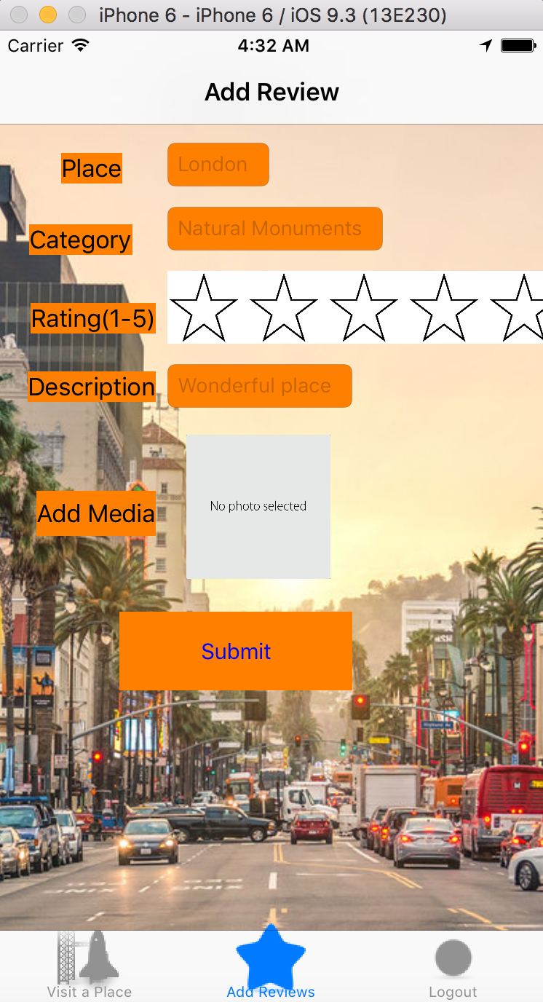

1. Hired success message will be displayed

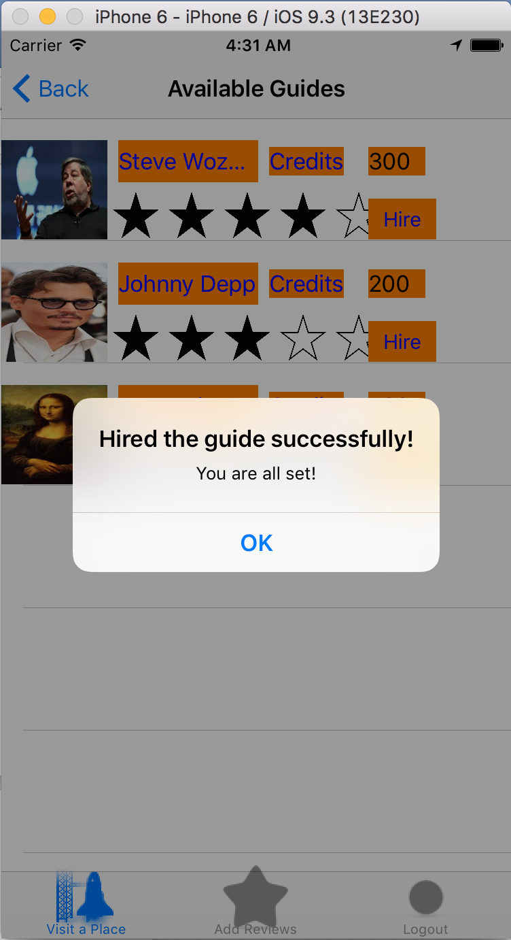

Presentation Link: http://slides.com/manjunathb/deck-4/fullscreen